2018-2019 DATES OF IMPORTANCE
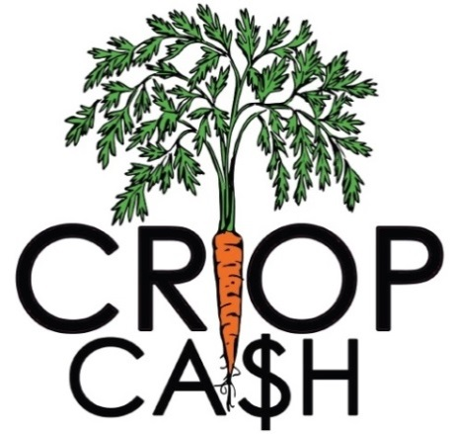
DATA ENTRY DEADLINES: SUMMER SEASON (May 1 – October 31)
Date | Requirement
June 7 | Enter data from May 1st – 31st
July 7 | Enter data from June 1st – 30th
August 7 | Enter data from July 1st – 31st
September 7 | Enter data from August 1st – 31st
October 7 | Enter data from September 1st – 30th
November 10 | Enter data from October 1st- 31st  End-of-Season Reporting Requirements Due

DATA ENTRY DEADLINES: WINTER SEASON (November 1 – April 30)
Date | Requirement
December 7 | Enter data from November 1st – 30th
January 7 | Enter data from December 1st – 31st
February 7 | Enter data from January 1st – 31st
March 7 | Enter data from February 1st – 28th
April 7 | Enter data from March 1st – 31st
May 10 | Enter data from April 1st - 30th  End-of-Season Reporting Requirements Due

REIMBURSEMENT SCHEDULE
Unless otherwise arranged with NOFA-VT, markets will be reimbursed on a set schedule. NOFA-VT will review your reimbursement based your market’s Crop Cash redemption in submitted via FM Tracks. To receive reimbursement, your market must:
1. Submit market data onto FM Tracks
2. Submit summary reports to NOFA-VT
3. Confirm Crop Cash redemption total due for reimbursement
Date | Reporting Period
July 21 | Reimbursement for May 1 – June 30
September 21 | Reimbursement for July 1 – August 31
November 21 | Reimbursement for September 1 – October 31  FINAL REIMBURSEMENT FOR SUMMER CROP CASH
January 21 | Reimbursement for November 1 – December 31
March 10 | Reimbursement for January 1 – February 28
May 10 | Reimbursement for March 1 – April 30  FINAL REIMBURSEMENT FOR WINTER CROP CASH

