For office use only:
Number | ___________
Date Received | ___ / ___ / ___

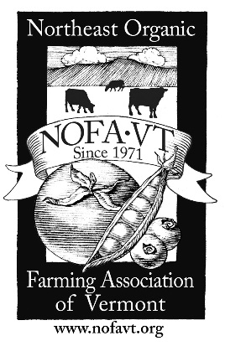
NOFA-VT Farm Share Program

Summer 2018 Participant Application

Applications accepted: March 1 – June 1.
Apply early – we will run out of funding. Submitting an application does not guarantee that you will receive funding to support the cost of your CSA share. Please allow up to 6 weeks for your application to be reviewed. If your application is approved, you will receive further instructions for how to pay your 50% cost responsibility and arrange the details of your share. Payment will be made directly to the CSA farm.
Your application will not be reviewed if it is incomplete. Please answer all questions before submitting.
For information about the Farm Share Program, please visit http://nofavt.org/farmshare or call 802-434-4122.
Name: __________________________________________________
Street: _________________________________ City: ______________________ State: VT Zip: __________
Email: _________________________________________________ Phone: _________________________
MAXIMUM INCOME ELIGIBILITY
 | 1 Person | 2 People | 3 People | 4 People | 5 People | 6 People | 7 People | 8 People
Weekly | $432 | $586 | $739 | $893 | $1,047 | $1,200 | $1,354 | $1,508
Monthly | $1,872 | $2,538 | $3,204 | $3,870 | $4,536 | $5,202 | $5,868 | $6,534
Household Size (including yourself): ______ Ages: _____, _____ , _____, _____, _____, _____, ____, _____
Do you currently receive 3SquaresVT/SNAP? Yes No
By checking the box here, you certify that your household income does not exceed the maximum income eligibility listed in the chart above: I certify that my household income meets the income requirement

Every CSA is different. Prior to applying to the Farm Share Program, NOFA-VT encourages applicants to contact the CSA farm directly, to learn more about the specifics of the share, including cost and pick-up, to make sure that it meets their needs and expectations. Please visit the NOFA-VT CSA Directory to learn more: www.nofavt.org/csa.
1) From what farm would you like to receive your CSA? _____________________________________________
2) What size share would you like to receive? __________________ Full Cost of Share: $__________
3) Have you participated in a CSA in that last 3 years? Yes No Where? __________________________
4) How did you hear about the Farm Share Program? ______________________________________________
5) Would you be interested in learning about other NOFA-VT programming and events? Yes No
I understand that if I am approved to participate in the Farm Share Program, I am required to pay at least 50% of the total share cost. I will make arrangements to pay this amount before the first CSA pick-up.
I accept these terms of the program and am prepared to pay 50% of the total share cost, if I am approved.
I accept these terms of the program and I am able to pay $________ of the total share cost, if I am approved.
Please submit your application in one of the following ways:
1) Mail to: NOFA-VT, P.O. Box 697, Richmond, VT 05477 2) Email to: jennie@nofavt.org

The information contained in this application will be used by designated NOFA-VT staff and program partners.
Contact Jennie Porter: Jennie@nofavt.org | 802-434-4122

