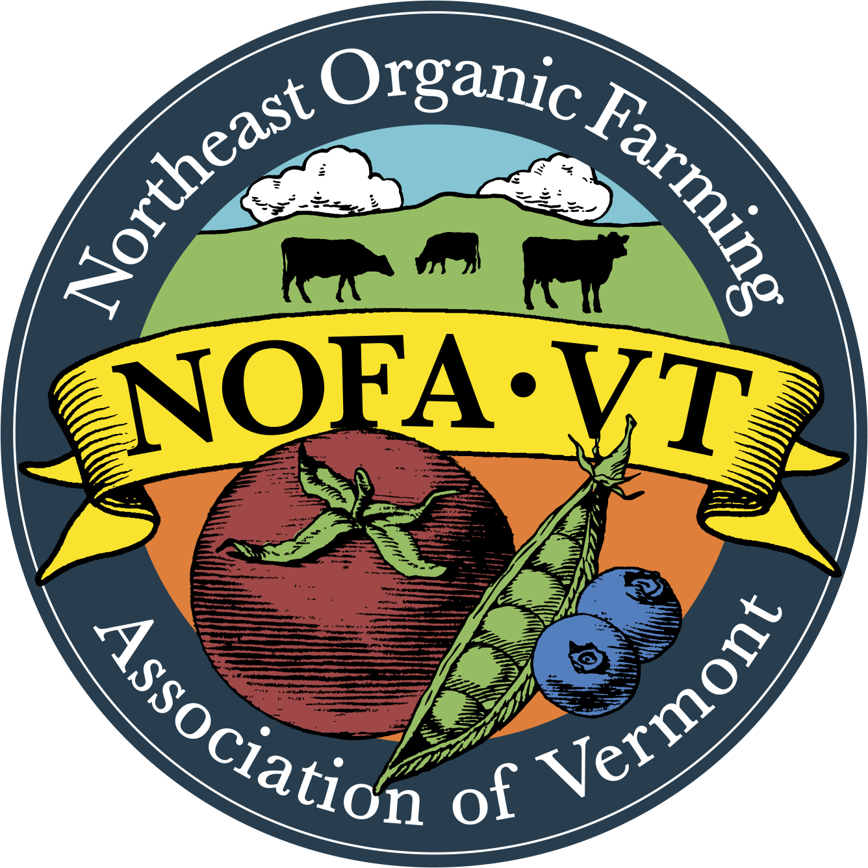
Senior Farm Share 2024 Participating Sites

Addison County
Pleasant Hills Apartments, Bristol
Bennington County
Applegate Apartments, Bennington
Readsboro Apartments THM Properties, Readsboro
Brookside, Bennington
Cora B Whitney, Bennington
Homestead Greene, North Bennington
Homestead Mews, North Bennington
Walloomsac Apartments, Bennington
Arlington Village Center- Shires Housing, Arlington
Shires Housing- Manchester, Manchester Center
The Fields, Manchester Center
The Meadows- THM, Manchester Center
Caledonia County
St Johnsbury House/Northern Senior Housing
Chittenden County
Elm Place, Milton
CSSL, Burlington
Fern Hill, Burlington
Heineberg Senior Housing, Burlington
Juniper, Burlington
Northgate Apartments, Burlington
Senior Towers, Winooski
Spring Gardens, Winooski
Thayer House, Burlington
The Courtyard, Winooski
The Terrace, Winooski
Town Meadow Senior Housing, Essex Junction
Whitcomb Terrace, Essex Junction
Whitcomb Woods, Essex Junction
Williston Woods, Williston
Grand Way Commons, South Burlington
Whitney Hill Homestead, Williston
Jeri Hill, Jericho
Allard Square, South Burlington
Wright House, Shelburne
Country Park, South Burlington
McKenzie House, Burlington
Kelley's Field, Hinesburg
Franklin County
Four Winds, St. Albans
Franklin Homestead & Carriage House
Missisquoi Manor, Richford
Grand Isle County
Bayview Crossing, South Hero
Round Barn Apartments, Grand Isle
Orange County
Riverbend, Chelsea
Orleans County
Lauredon Village Apartments, Greensboro
Derby Line Gardens, Derby Line
Governor Prouty Apartments, Newport
Governor's Mansion, Newport
Newport Senior Apartments, Newport
Scenic View, Westfield
Shattuck Hill Mobile Home Park, Newport
Rutland County
Bardwell House, Rutland
Hickory Street, Rutland
Linden Terrace, Rutland
Parker House, Rutland
Sheldon Towers, Rutland
Templewood Court, Rutland
Washington County
58 Barre Street Apartments, Montpelier
BHA Washington Apartments, Barre
Depot Apartments, Bethel
Dogwood Glen, Northfield
Downstreet Apartments, Barre
Fairground Apartments, Waterbury
Green Mountain Apartments, Northfield
Lane Shop Apartments, Montpelier
Morse Block, Barre
Pioneer Apartments, Montpelier
Prospect Street Apartments, Montpelier
Quarry Hill Apartments, Graniteville
Jefferson Apartments, Barre
Tilden House, Barre
Windham County
Butterfield Common, West Dover
Valley Cares Independent Living, Townshend
Westgate Housing Inc., Brattleboro
Windsor County
Park House, Rochester
Windsor Village, Windsor
Gill Terrace 2 Retirement Apts, Ludlow
Mellishwood Senior Apts, Woodstock

