HOW TO SHEET: Youth Farmers’ Market Day

1. Choose a date for your Youth Farmers’ Market (YFM) and assign a community member to act as the organizer for the event. The organizer will respond to calls or emails from youth vendors, keep track of those signing up and find someone to help out on YFM Day.

2. Create a poster or flyer (see template) to advertise the event and solicit participants – this poster must include information about when and where the event will take place, what the youth may vend and what they need to bring to be prepared, and how to contact the organizer in order to sign up.

3. Send copies of the poster/flyer to the contacts in your region. Schools will help distribute if you get the flyer out early enough in the year. Otherwise, summer camps, libraries and general stores, 4-H groups, girl scouts and boy scouts or your market e-mail list are good contacts.

4. Contact your regional NOFA Vermont Farm to Community Mentor for ideas and support (contacts below), if you need it.

5. Hang up posters/flyers in libraries, food markets, churches, and any other public setting where you’re allowed. Hand out flyers at the weekly farmers’ markets.

6. Send the flyer to area newspapers 3 WEEKS BEFORE THE EVENT IS SCHEDULED

7. Day of the event: the organizer should find someone to be on hand to orient youth vendors when they first arrive and to check in with them at the end of the event. Often, it’s great to have a couple of special youth activities, not only for the youth vendors but also for other children who come that day.

FOR MORE INFORMATION: Please contact Erin Buckwalter, NOFA Vermont Direct Marketing & Community Food Security Coordinator, at erin@nofavt.org or 434-4122.

FARM TO COMMUNITY MENTORS CONTACT:

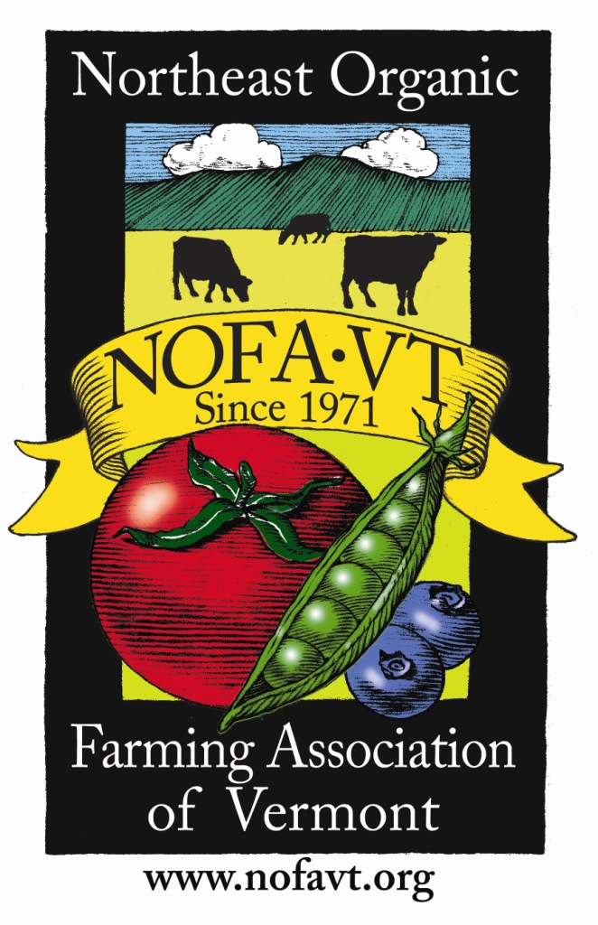
Addison & South Chittenden Andrea Scott • 802-897-2779 • andrea.scott2955@gmail.com
Central & North Chittenden John Connell • 802-899-2375 • jc6greenmont@gmail.com
Bennington and Rutland Scout Proft • 802-362-2290
Franklin & Grand Isle Virginia Holiman • 802-868-2295 • vholiman@hotmail.com
Lamoille & Southern Orleans Selina Rooney • 802-498-4030 • selinarooney@myfairpoint.net
Northern Orleans & Caledonia Melissa Bridges • 802-748-8742 • village_greens@yahoo.com
Orange & Washington Megan Hartigan • (802) 793-6574 • meglizhart@gmail.com
Windsor Amy Richardson • 802-436-7017 • farmtoschool@yahoo.com
Windham Lisa Holderness • 802-254-3540 • deerridgefarm@comcast.net

Seeking all children and youth interested in selling homegrown or homemade products!
Insert your market logo here
Please sign up for and come to:
YOUTH FARMERS’ MARKET DAY at the _________________________ Farmers’ Market 2012!

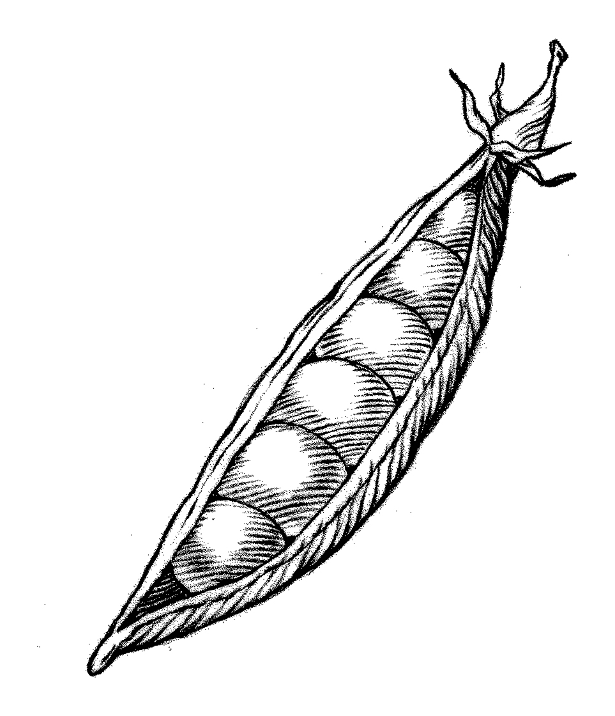
DETAILS:
DATE:
PLACE:
TIME:

WHAT YOU MAY SELL: You may sell items you have grown and/or made with minimum adult help.

PARENTS: it is very important that the children grow or make something mostly on their own.
Examples: garden produce (vegetables/fruit), baked goods, flowers, works of wood, cloth, clay, paint, pen/pencil drawings or cards.

What you need to bring:
• Attractive sign. Name your farm/business, and put it on a sign!
• Your products; information you may have to hand-out describing what you grow/make.
• Card table (or similar size table no more that 3ftx3ft for your items and display (you
may share with a friend).
• Money box and money to make change.
• Notebook to keep track of what you sell–we need a ‘total sales’ number at the end of the market.
• Samples for people to taste/look at; and/or demonstration of what you do (e.g., spinning, knitting, wood-carving)
• Yourself, as the grower or craftsperson. (Children 12 and under must be accompanied
by an adult helper for the entire market)
• Your products need to be sold at a competitive price. Please check with other market vendors before making your pricing signs.
• For this special event, no fee will be charged for you to sell. However, spaces will be limited, so sign up early!

Sign-up Deadline:
To sign up by (date), or for more information, please contact:

